Project Analysis Report

On

**“DR. ON A CLICK: AI Based Health Care Solution”**

Group No.: 6

Submitted by:

Abha Dilawari: 2000140130002

Aditya Pal: 2100140139001

Hiba Siddiqui: 2100140139002

Under the guidance of:

Dr. Shailesh Saxena

Submitted to:

Ms. Sakshi Goel

Project Incharge



*Department of Information Technology*

**Shri Ram Murti Smarak College of Engineering & Technology, Bareilly Dr.A.P.J. Abdul Kalam Technical University, Lucknow**

**Acknowledgment**

We extend our heartfelt gratitude to Dr. Shailesh Saxena, our guide at the Department of Information Technology, Shri Ram Murti Smarak College of Engineering & Technology, Bareilly, for his unwavering support and insightful guidance throughout this project.

Our appreciation also goes to Columbia University for their valuable "Disease-Symptom Knowledge Database," which significantly enriched our research.

Special thanks to our team members, Abha Dilawari, Aditya Pal, and Hiba Siddiqui, for their dedicated contributions and collaboration.

We express our thanks to everyone who has been part of this journey, making this project a reality.

# Abstract

The project 'Dr. ON A CLICK' represents a revolutionary intersection of cutting-edge technology and healthcare, envisioning a future where medical care is seamlessly accessible and technologically advanced. At its core, this innovative platform redefines the patient experience by introducing a user-friendly online interface, facilitating effortless connections between patients and healthcare professionals. The objectives encompass the integration of AI-based disease prediction, convenient online appointments, secure digital record-keeping, and an emergency response system.

The platform's groundbreaking features include virtual medical consultations via WhatsApp video calls, leveraging the current era of remote healthcare. The predictive power of the regression-based AI module enhances diagnostic precision, contributing to early disease detection and personalized medical interventions. Furthermore, a robust digital locker ensures secure storage of medical records, prescriptions, and essential documents, streamlining record-keeping and ensuring easy access to critical healthcare information.

The ongoing project status reveals the successful completion of the AI module development, marking a significant milestone. The MSSQL database is in place, providing a secure foundation for managing patient data. As the next steps unfold, the focus shifts towards UI design, software coding, deployment planning, and API integration. Each phase is meticulously designed to align with the project's overarching vision of embracing digital technologies for a future that adapts to evolving patient needs and industry changes.

In conclusion, 'Dr. ON A CLICK' stands poised to redefine the healthcare landscape. By seamlessly integrating technology, AI, and innovative features, the platform aims to provide unparalleled convenience, accessibility, and security to patients while empowering healthcare providers to deliver exceptional care through cutting-edge digital solutions. The project's abstract encapsulates a vision for a future where healthcare is not just a service but a holistic and responsive experience.

**Table of contents**

Abstract iii

I. INTRODUCTION 1

II. OBJECTIVE 2

III. REQUIREMENT SPECIFICATIONS 3

1. Software/Technology Requirement 3

2. Hardware Requirement 3

IV. METHODOLOGY 4

A. Methodology for 'Dr. ON A CLICK' Healthcare Platform Development 4

1. Discovery and Planning: 4

2. AI Module Development: 4

3. UI/UX Design: 4

4. Software Coding and Integration: 5

5. Deployment Planning: 5

6. API Integration: 5

7. Monitoring and Optimization: 5

8. Contingency Planning: 6

9. Documentation: 6

10. Post-Deployment Support: 6

11. Collaboration and Communication: 6

B. Methodology for AI Disease Detection in 'Dr. ON A CLICK': 8

1. Data Collection: 8

2. Data Preprocessing: 8

3. Model Selection and Training: 8

4. Flask Application Development: 8

5. Flask Application Structure: 8

6. Local Server Setup: 9

7. User Interaction: 9

8. Result Presentation: 9

9. Deployment: 9

10. Conclusion: 9

V. MODULE DESCRIPTION 11

VI. WORK STATUS 14

1. AI Module Development: 14

2. Database Design and Implementation: 17

3. Module-wise Progress: 19

4. Improvements and Considerations: 20

VII. CONCLUSION 21

VIII. References 22

**List of Figures**

Figure 1: Flow Diagram of our Process 7

Figure 2: AI Disease Detection in 'Dr. ON A CLICK' 10

Figure 3: Home Page of AI Disease Detection in 'Dr. ON A CLICK' 14

Figure 4: Raw data Collected from Columbia University, "Disease-Symptom Knowledge Database." [9] 15

Figure 5: Training Data in CSV Format 15

Figure 6: Test Data in CSV Format 16

Figure 7: Model Training and Testing 16

Figure 8: Result page of AI Disease Detection in 'Dr. ON A CLICK' 16

Figure 9: Schema of Database 17

Figure 10:View of Database 18

Figure 11: Modules 19

Figure 12: Progress 20

# INTRODUCTION

Introducing 'Dr. ON A CLICK': A Paradigm-Shifting Healthcare Solution at the Nexus of Technology and Medicine. This groundbreaking platform seeks to transform the healthcare experience by providing a seamless online interface, empowering patients to effortlessly connect with healthcare professionals.

'Dr. ON A CLICK' reimagines the way medical appointments are scheduled, offering convenient booking options that eliminate the hassle of time-consuming phone calls or in-person clinic visits.

Our platform facilitates virtual medical consultations via WhatsApp video calls, allowing patients to seek expert medical guidance from the comfort of their homes, especially valuable in today's era of remote healthcare.

Leveraging cutting-edge AI technology, 'Dr. ON A CLICK' features a regression-based module that predicts disease possibilities based on patient-entered symptoms, enhancing diagnostic precision and medical decision-making.

With a robust digital locker, 'Dr. ON A CLICK' ensures secure storage of medical records, prescriptions, and essential documents, streamlining record-keeping and ensuring easy access to critical healthcare information.

In critical moments, our application includes an SOS button that promptly alerts both emergency contacts and designated healthcare professionals, bolstering patient safety and ensuring rapid medical assistance when emergencies arise.

'Dr. ON A CLICK' stands ready to redefine the healthcare landscape, providing unparalleled convenience, accessibility, and security to patients while empowering healthcare providers to deliver exceptional care through cutting-edge digital solutions.

# OBJECTIVE

The healthcare system is rapidly evolving with the integration of AI-based disease diagnosis, which aims to predict diseases based on symptoms, improving accuracy and early detection. To enhance healthcare accessibility, an online platform is being developed for easy appointment scheduling and virtual consultations through WhatsApp. Additionally, a secure digital locker system will store and share medical records and documents conveniently. An SOS button feature is included for emergencies, prioritizing patient experience while maintaining data security and privacy. The vision is to embrace digital technologies for the future, adapting to evolving patient needs and industry changes.

# REQUIREMENT SPECIFICATIONS

## Software/Technology Requirement

|  |  |  |
| --- | --- | --- |
| **Sr. No.** | **Item** | **Specification** |
| 1. | Platform / IDE | 1. PyCharm 2. Visual Studio |
| 2. | Programing Language | 1. Python 2. C# 3. HTML 4. CSS 5. JS |
| 3. | Framework | 1. ASP.Net 2. Flask |
| 4. | Database | 1. MSSQL |
| 5. | Operating System | 1. Windows 11 |
| 7. | Data Handling | 1. MS Excel 2. CSV |
| 8. | Browser | 1. Google chrome |
| 9. | Algorithm | 1. Random Forest |
| 10. | UI/UX Designing Tool | 1. Figma 2. Adobe XD |
| 11. | Other | 1. Lucid.app 2. Git 3. GitHub |

## Hardware Requirement

|  |  |  |
| --- | --- | --- |
| **Sr. No.** | **Item** | **Specification** |
| 1. | Processor | Intel i5 11th gen |
| 2. | Memory | 8 GB DDR4 |
| 3. | GUP | Intel Iris Xe |
| 4. | Storage | 100 GB |
| 5. | Internet Connection | 30 Mbps |

# METHODOLOGY

## Methodology for 'Dr. ON A CLICK' Healthcare Platform Development

### Discovery and Planning:

* + 1. Stakeholder Meetings: Conduct detailed meetings with key stakeholders, including healthcare professionals, users, and technical experts, to gather requirements and insights.
    2. Market Research: Analyze existing healthcare platforms, user expectations, and technological trends to inform the development strategy.
    3. Scope Definition: Clearly define the scope of the project, outlining features, functionalities, and the overall vision for 'Dr. ON A CLICK.'
    4. Timeline and Milestones: Develop a comprehensive timeline with achievable milestones, ensuring a structured and efficient development process.

### AI Module Development:

* + 1. Algorithm Selection: Choose appropriate algorithms for AI-based diagnosis, considering accuracy, scalability, and interpretability.
    2. Data Preparation: Curate and preprocess healthcare data to train and validate machine learning models.
    3. Model Development: Implement machine learning models using frameworks like Flask, ensuring compatibility with the overall platform architecture.
    4. Testing and Validation: Rigorous testing of the AI module to ensure accurate symptom analysis and disease predictions.

### UI/UX Design:

* + 1. Wireframing: Utilize tools like Sketch for wireframing, iterating on user interface designs based on stakeholder feedback.
    2. Prototyping: Develop interactive prototypes using Figma and Adobe XD to simulate user interactions and refine design elements.
    3. Collaborative Design: Foster collaboration among designers, developers, and stakeholders using collaborative tools to ensure alignment with project goals.
    4. User Testing: Conduct usability testing with tools like UsabilityHub to gather user feedback on design elements and improve overall user experience.

### Software Coding and Integration:

* + 1. Programming Languages: Use versatile languages like Python for AI integration and Asp.NET for web-based functionalities.
    2. Web Development Frameworks: Employ frameworks like .NET for backend development, ensuring a robust and scalable architecture.
    3. Integration Testing: Conduct thorough integration testing to ensure seamless communication between different modules, addressing any compatibility issues.
    4. Security Measures: Implement encryption protocols and conduct security audits to fortify the platform against potential cyber threats.

### Deployment Planning:

* + 1. Cloud-Based Architecture: Leverage cloud services (AWS, Azure, or Google Cloud) for scalable and reliable server infrastructure.
    2. Load Balancing: Implement load balancing strategies to distribute traffic and prevent server overload.
    3. Scalability Measures: Incorporate auto-scaling mechanisms for dynamic resource adjustments based on user demand.
    4. User Training: Develop training materials and communication strategies for users to adapt seamlessly to the new platform.

### API Integration:

* + 1. API Identification: Conduct a thorough analysis to identify relevant APIs aligning with the platform's goals.
    2. Scalability Assessment: Assess selected APIs for scalability to accommodate the platform's growth.
    3. Integration Testing: Rigorous testing of API integrations to ensure seamless communication and data exchange.
    4. Data Security: Implement security protocols to safeguard data exchanged through APIs.

### Monitoring and Optimization:

* + 1. Continuous Monitoring: Implement tools for continuous monitoring of platform performance, user interactions, and system health.
    2. Analytics: Utilize analytics to gather insights into user behavior, allowing for continuous optimization.
    3. Optimization Strategies: Apply ongoing optimization strategies based on monitoring data to enhance platform functionality and user experience.

### Contingency Planning:

* + 1. Rollback Strategies: Develop contingency plans and rollback strategies in case of unforeseen issues during deployment.
    2. Risk Mitigation: Identify potential risks and develop mitigation plans to minimize disruptions to users.

### Documentation:

* + 1. Technical Documentation: Create comprehensive technical documentation covering codebase, APIs, and overall system architecture.
    2. User Guides: Develop user guides and documentation to assist both healthcare professionals and users in navigating the platform effectively.

### Post-Deployment Support:

* + 1. User Support: Provide ongoing user support to address queries, issues, and feedback.
    2. Iterative Development: Continuously iterate on the platform based on user feedback, technological advancements, and evolving healthcare needs.

### Collaboration and Communication:

* + 1. Regular Meetings: Schedule regular meetings with stakeholders for updates, feedback, and alignment.
    2. Collaborative Tools: Utilize collaborative tools for seamless communication and coordination among team members.

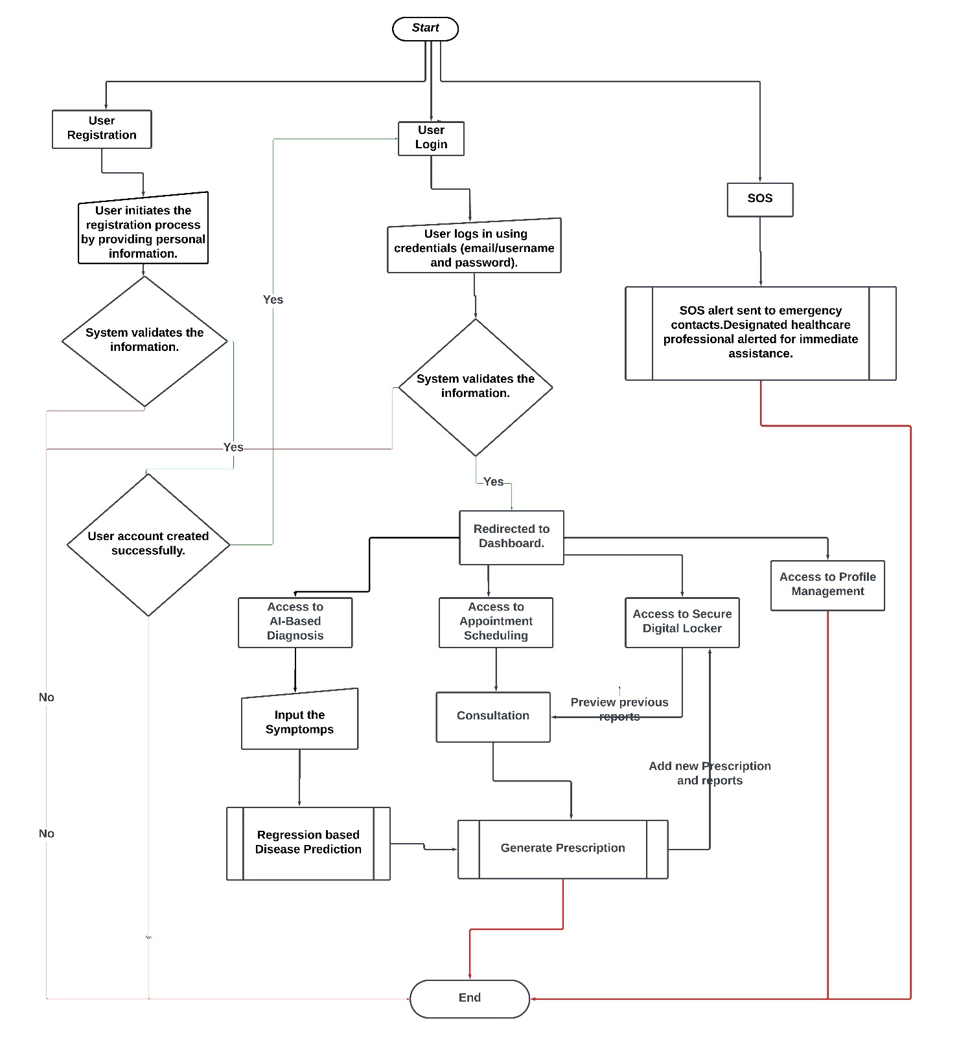

Figure 1: Flow Diagram of our Process

## Methodology for AI Disease Detection in 'Dr. ON A CLICK':

### Data Collection:

* + 1. Data was collected from the Columbia University Disease-Symptom Knowledge Database [9].

### Data Preprocessing:

* + 1. The collected data was processed and converted into a CSV file.
    2. The data was split into training and testing datasets for model evaluation.

### Model Selection and Training:

* + 1. A pre-built Random Forest model was selected for disease prediction.
    2. The model was trained using the training dataset, with features and labels extracted as follows:
       1. Length of Training Data: (4920, 134)
       2. Training Features: (4920, 132)
       3. Training Labels: (4920,)
       4. Length of Test Data: (42, 133)
       5. Test Features: (42, 132)
       6. Test Labels: (42,)

### Flask Application Development:

* + 1. A Flask web application was developed to provide a user-friendly interface for symptom input and disease prediction.
    2. The Flask app includes an HTML form where users can select symptoms using checkboxes.
    3. The form submission triggers the prediction route, and the result is displayed on a new page.

### Flask Application Structure:

* + 1. The Flask app includes routes for both the home page and the prediction result page.
    2. The home page presents a form with checkboxes for selecting symptoms.
    3. JavaScript is used to validate form submission, ensuring at least one symptom is selected.
    4. The prediction result page displays the predicted disease based on the selected symptoms.

### Local Server Setup:

* + 1. The Flask app is configured to run on a local server, and the application can be accessed through a web browser.
    2. The app dynamically determines the local IP address for accessibility.

### User Interaction:

* + 1. Users interact with the web interface by selecting symptoms and submitting the form.
    2. The selected symptoms are sent to the server, and the trained model predicts the associated disease.

### Result Presentation:

* + 1. The predicted disease is presented to the user on a separate page, along with a link to navigate back to the symptom selection page.

### Deployment:

* + 1. The Flask application is deployed to be accessible on the local network.
    2. The deployment allows users to access the disease prediction system through their web browsers.

### Conclusion:

* + 1. The developed methodology incorporates data collection, model training, and web application deployment to create an interactive and accessible AI-based disease prediction system.

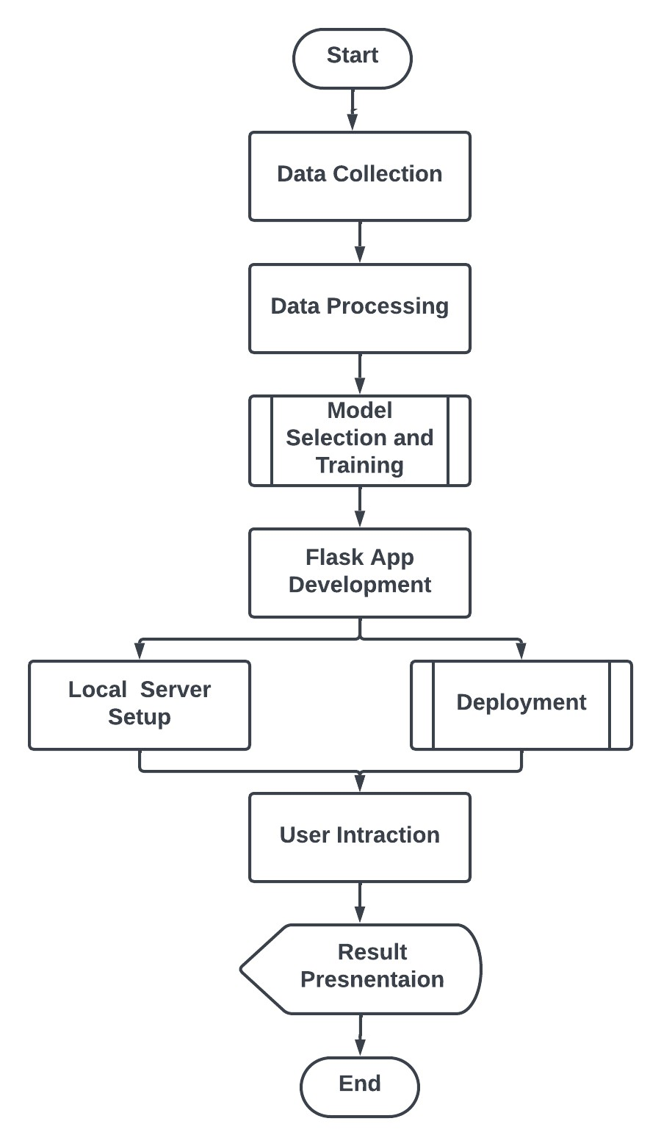

Figure 2: AI Disease Detection in 'Dr. ON A CLICK'

# MODULE DESCRIPTION

1. **Registration:**
   1. Users initiate their journey on the healthcare platform by providing essential personal information during the registration process. This includes details such as full name, contact number, and a valid email address.
   2. Secure password creation and validation ensure the confidentiality and integrity of user accounts.
   3. Email verification or other authentication methods are implemented to validate the user's identity and enhance security.
2. **Login:**
   1. A robust authentication mechanism ensures secure login, protecting user accounts from unauthorized access.
   2. Users can log in using their registered email or username, along with a password.
   3. Security features like multi-factor authentication may be implemented for an additional layer of protection.
3. **Dashboard:**
   1. The dashboard provides a personalized and centralized view for each user.
   2. Upcoming appointments, recent diagnoses, and other relevant information are displayed in a user-friendly manner.
   3. Quick access links and shortcuts to key features enhance user navigation and experience.
4. **AI-Based Diagnosis:**
   1. Users input their symptoms and medical history into the system.
   2. The AI system employs sophisticated algorithms and machine learning models to analyze the input data, providing possible disease predictions and tailored recommendations.
   3. Users may receive suggestions for further diagnostic tests or be directed to schedule a consultation based on the AI analysis.
5. **Appointment Scheduling:**
   1. An intuitive interface allows users to view the availability of healthcare providers and schedule appointments at their convenience.
   2. Users can specify the reason for the appointment and any specific preferences.
   3. Automated appointment reminders help reduce no-shows and ensure better adherence to scheduled appointments.
6. **Virtual Consultation:**
   1. Users can engage in real-time video calls with healthcare professionals for virtual consultations.
   2. Secure and HIPAA-compliant communication channels ensure the privacy and confidentiality of medical discussions.
   3. Features such as file sharing and screen sharing enhance the effectiveness of virtual consultations.
7. **Secure Locker:**
   1. Users can securely upload and store sensitive medical records, prescriptions, and documents in a digital locker.
   2. Encryption and access controls ensure the confidentiality and privacy of stored information.
   3. Easy retrieval and organization features facilitate quick access to critical medical documents.
8. **Document Sharing:**
   1. Seamless integration allows users to share medical documents, test reports, and records with their healthcare providers directly through the platform.
   2. Version control and audit trails ensure the accuracy and traceability of shared documents.
   3. Secure communication channels prevent unauthorized access during document sharing.
9. **Profile Management:**
   1. Users have the ability to update and manage their profile information, including contact details, emergency contacts, and insurance information.
   2. The platform may provide personalized health insights and recommendations based on the user's updated profile and medical history.
   3. Preferences for communication and appointment notifications can be customized within the profile management module.

# WORK STATUS

As of the current evaluation, the 'Dr. ON A CLICK' healthcare platform is undergoing development across various modules. The detailed progress and status for each module are outlined below:

### AI Module Development:

* 1. ***Description***: The AI module development represents a significant achievement, particularly with the completion of a regression-based model for disease diagnosis. This breakthrough enhances predictive analytics, allowing accurate forecasting of diseases based on patient-entered symptoms.
  2. ***Milestone:*** The regression-based model is successfully completed, showcasing advanced machine learning capabilities and positioning 'Dr. ON A CLICK' as an innovative solution in AI-driven healthcare.
  3. ***GitHub Repository:*** The AI Disease Detection module is completed, and its repository is published on GitHub.

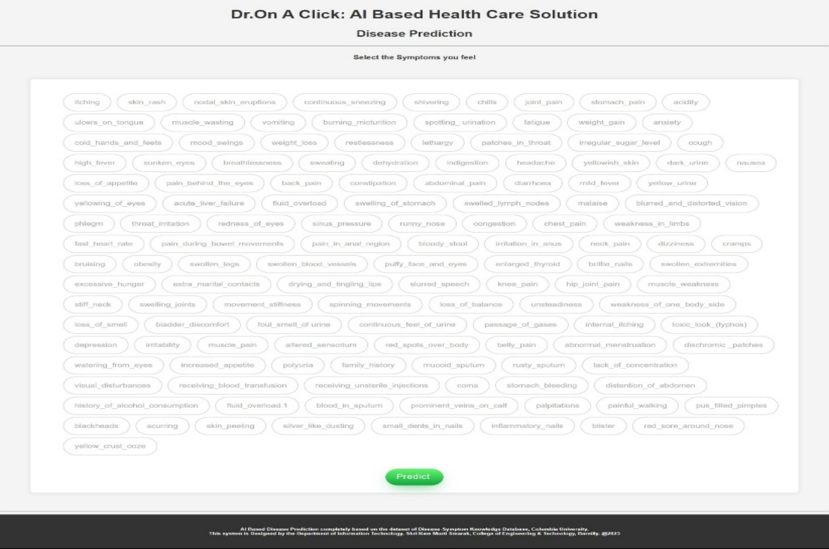

Figure 3: Home Page of AI Disease Detection in 'Dr. ON A CLICK'

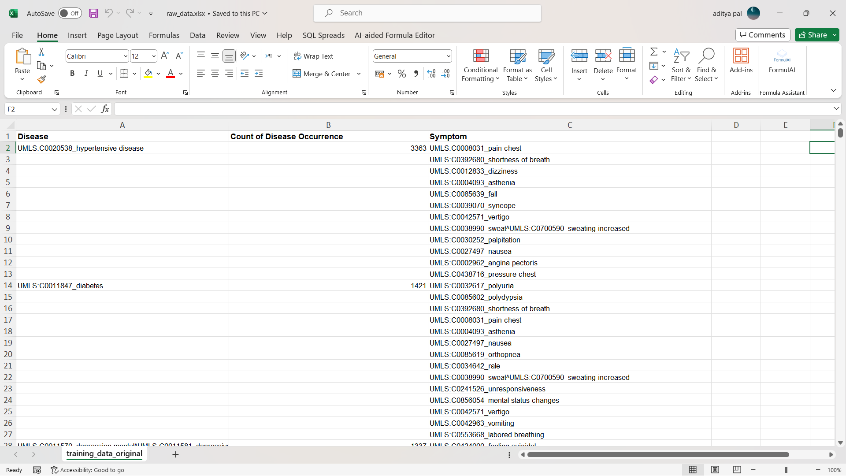

Figure 4: Raw data Collected from Columbia University, "Disease-Symptom Knowledge Database." [9]

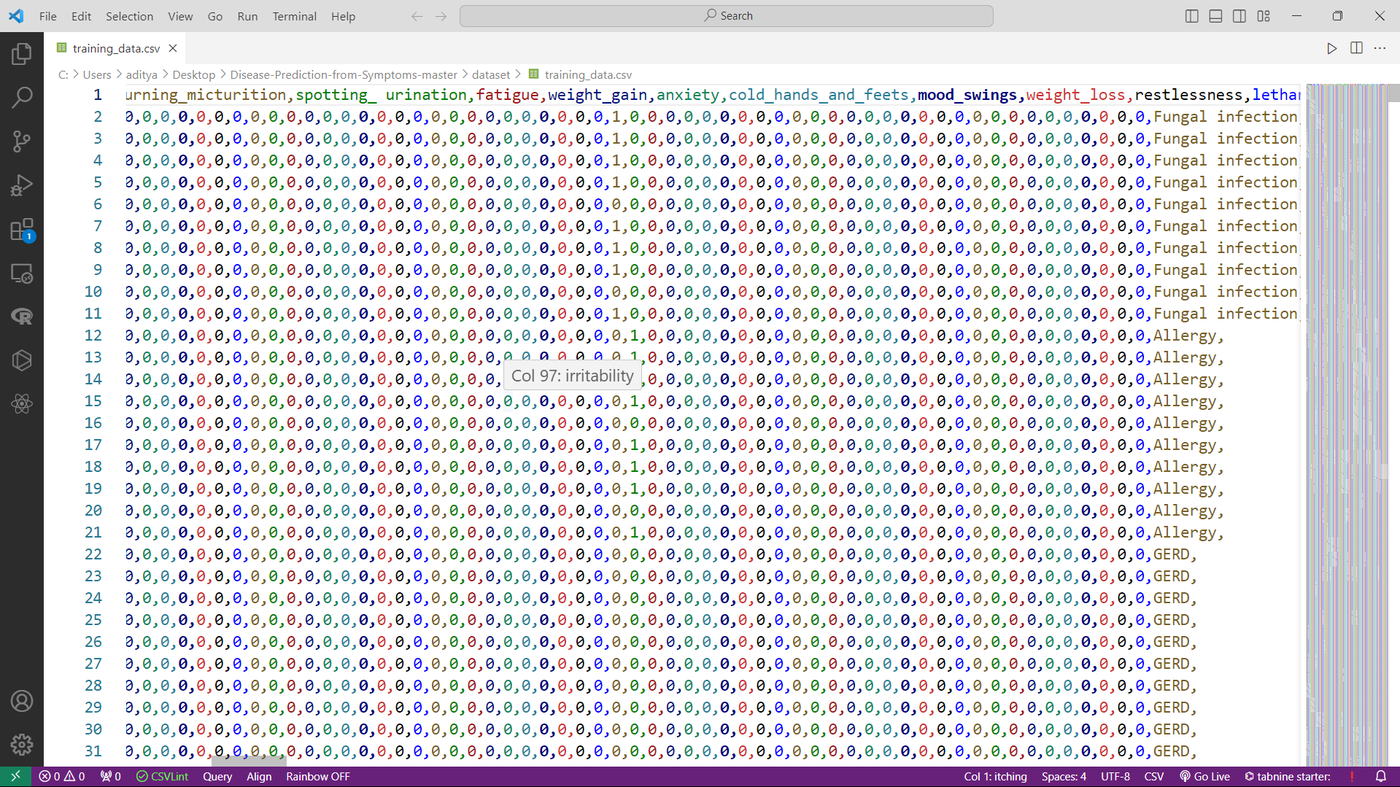

Figure 5: Training Data in CSV Format

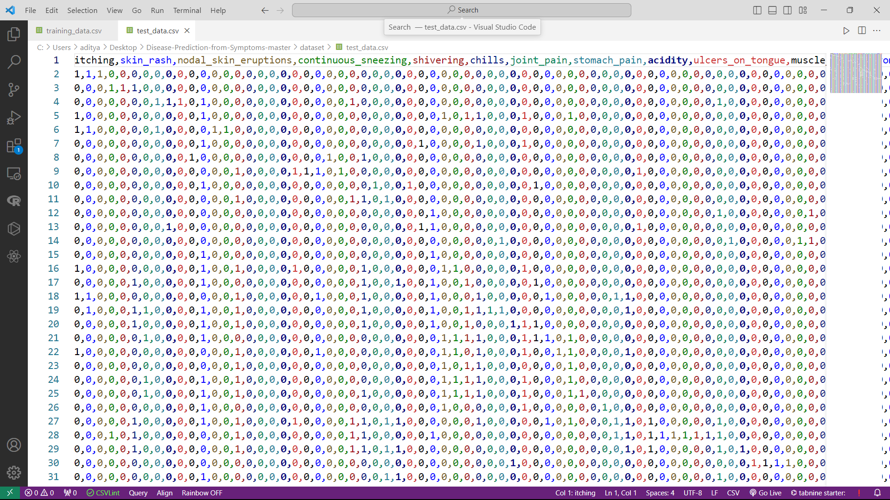

Figure 6: Test Data in CSV Format

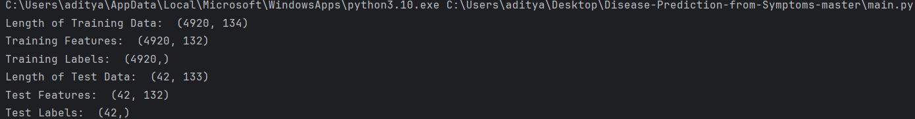

Figure 7: Model Training and Testing

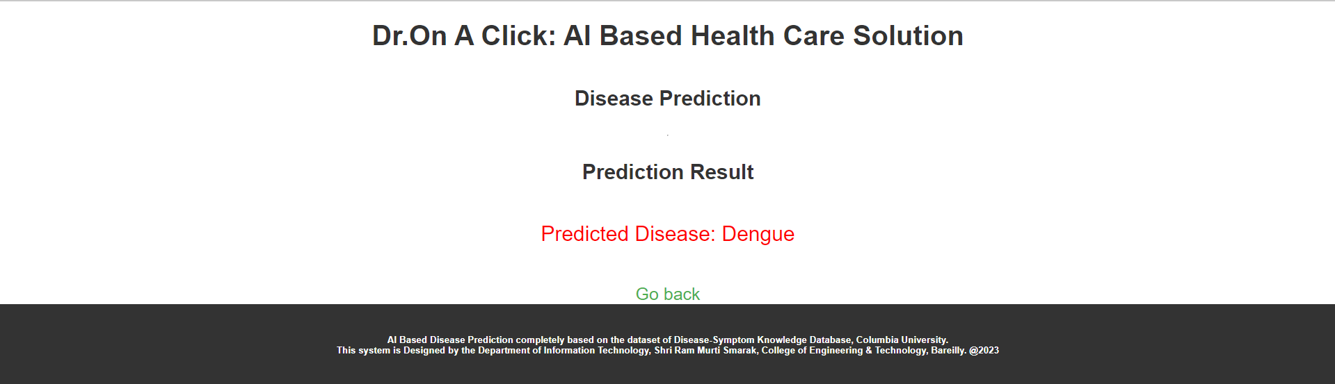

Figure 8: Result page of AI Disease Detection in 'Dr. ON A CLICK'

### Database Design and Implementation:

* 1. ***Description:*** The MSSQL database has been meticulously designed with a relational data model, encompassing key entities like patients, healthcare providers, appointments, and medical records. Foreign key relationships and constraints maintain data integrity, supporting efficient information retrieval and seamless module integration.
  2. ***Security Measures:*** Robust security measures, including user authentication, role-based access controls, and data encryption, have been implemented. Sensitive patient information is stored securely, with regular backups and a recovery strategy in place for data protection.
  3. ***Scalability:*** The database design is scalable, accommodating expanding datasets and evolving user needs.

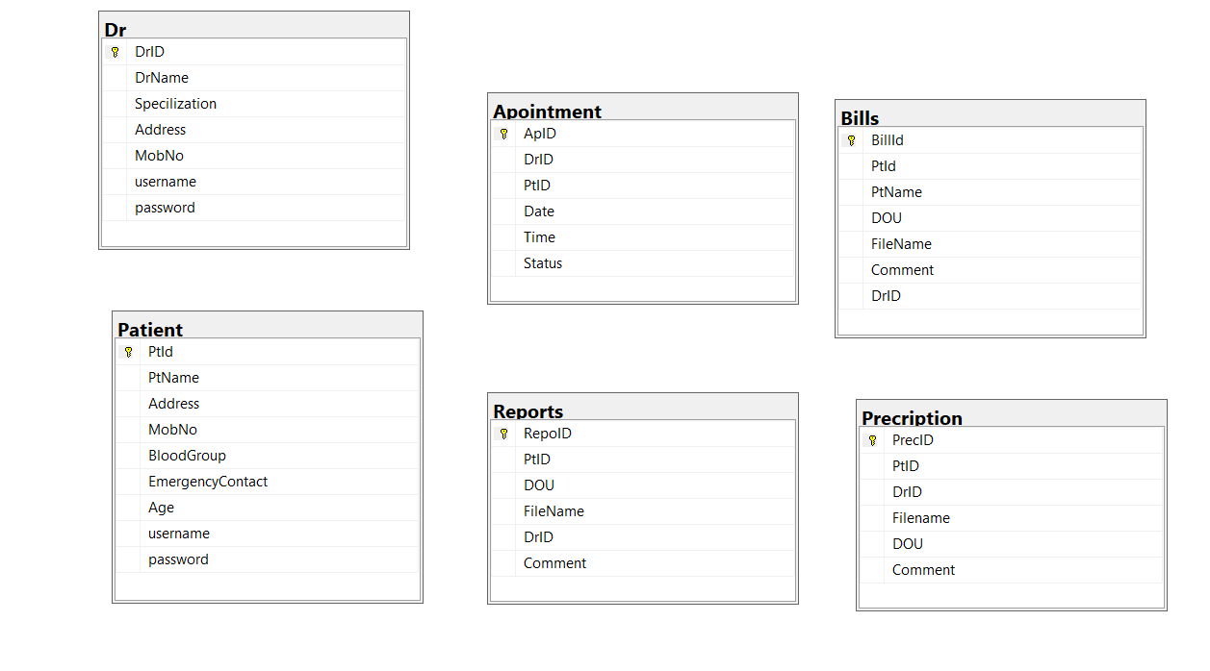

Figure 9: Schema of Database

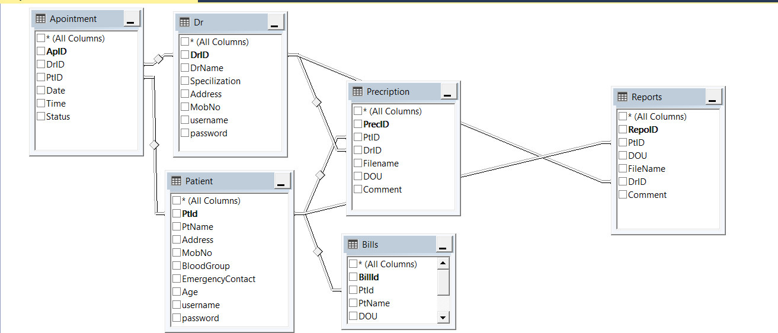

Figure 10:View of Database

### Module-wise Progress:

* 1. Registration: 10% - Pending
  2. Login: 10% - Pending
  3. Dashboard: 10% - Pending
  4. AI Disease Diagnosis: 20% - Completed
  5. Appointment Scheduling: 10% - Pending
  6. Virtual Consultation: 10% - Pending
  7. Secure Locker: 10% - Pending
  8. Document Sharing: 10% - Pending
  9. Profile Management: 10% - Pending

Figure 11: Modules

Figure 12: Progress

### Improvements and Considerations:

* 1. ***Overall Progress:*** While the AI Disease Diagnosis module is completed, other modules are in the early stages. Efforts may need to be redistributed for balanced progress.
  2. ***Balanced Progress:*** Redistribute efforts among modules to prevent bottlenecks and ensure even completion.
  3. ***Timeline Considerations:*** Evaluate and adjust timelines for each module to meet project deadlines.
  4. ***Communication:*** Maintain transparent communication channels among team members for addressing challenges promptly.
  5. ***Collaboration:*** Encourage collaboration among team members to foster synergy and a holistic understanding of the project.

# CONCLUSION

In conclusion, 'Dr. ON A CLICK' is not merely a healthcare platform; it represents a paradigm shift in the way healthcare is accessed and delivered. By seamlessly integrating technology, AI, and innovative features, the platform stands ready to redefine the healthcare landscape, providing unparalleled convenience, accessibility, and security to patients while empowering healthcare providers to deliver exceptional care through cutting-edge digital solutions.

As the project progresses through its various phases, 'Dr. ON A CLICK' remains committed to its vision of embracing digital technologies for the future, adapting to evolving patient needs, and contributing to the transformation of the healthcare industry. The journey towards a more accessible, responsive, and technologically advanced healthcare system is underway, with 'Dr. ON A CLICK' leading the way.

# References

1. Darkins, "Telemedicine and Telehealth: Principles, Policies, Performance, and Pitfalls," in Telemedicine and Telehealth: Principles, Policies, Performance, and Pitfalls. Available: [Online]. Available: https://[www.ncbi.nlm.nih.gov/books/NBK207146/.](http://www.ncbi.nlm.nih.gov/books/NBK207146/)
2. M. K. Amatayakul, "Electronic Health Records: A Practical Guide for Professionals and Organizations," in Electronic Health Records: A Practical Guide for Professionals and Organizations. Available: [Online]. Available: https://[www.ahima.org/Topics/Electronic-](http://www.ahima.org/Topics/Electronic-) Health-Records.
3. J. A. Hesse et al., "Health Data Sharing: Privacy and Data Security Issues in Health Information Exchange," in Health Data Sharing: Privacy and Data Security Issues in Health Information Exchange. Available: [Online]. Available: https://[www.ncbi.nlm.nih.gov/pmc/articles/PMC3655918/.](http://www.ncbi.nlm.nih.gov/pmc/articles/PMC3655918/)
4. H. Tapia et al., "Design of an Emergency Alert System for Healthcare Institutions," in Design of an Emergency Alert System for Healthcare Institutions. Available: [Online]. Available: https://[www.researchgate.net/publication/220613215_Design_of_an_Emergency_Alert_S](http://www.researchgate.net/publication/220613215_Design_of_an_Emergency_Alert_S) ystem_for_Healthcare_Institutions
5. Farouk et al., "Security and Privacy Issues in Electronic Health Records: A Comprehensive Study," in Security and Privacy Issues in Electronic Health Records: A Comprehensive Study. Available: [Online]. Available: https://[www.researchgate.net/publication/261461648_Security_and_Privacy_Issues_in_E](http://www.researchgate.net/publication/261461648_Security_and_Privacy_Issues_in_E) lectronic_Health_Records_A_Comprehensive_Study.
6. K. Hawthorne et al., "Mobile Health (mHealth) in Diabetes Care: A Systematic Review," in Mobile Health (mHealth) in Diabetes Care: A Systematic Review. Available: [Online]. Available: https://[www.ncbi.nlm.nih.gov/pmc/articles/PMC7019733/.](http://www.ncbi.nlm.nih.gov/pmc/articles/PMC7019733/)
7. J. Lake, "Integrated Health Information Architecture: Power to the Users," in Integrated Health Information Architecture: Power to the Users. Available: [Online]. Available: https://[www.researchgate.net/publication/220967907_Integrated_Health_Information_Ar](http://www.researchgate.net/publication/220967907_Integrated_Health_Information_Ar) chitecture_Power_to_the_Users.
8. E. A. Akl et al., "Factors Affecting the Adoption of Telemedicine - A Systematic Literature Review," in Factors Affecting the Adoption of Telemedicine - A Systematic Literature Review. Available: [Online]. Available: <https://journals.plos.org/plosone/article?id=10.1371/journal.pone.0033139/>.
9. Columbia University, "Disease-Symptom Knowledge Database." Available: [Online]. <https://people.dbmi.columbia.edu/~friedma/Projects/DiseaseSymptomKB/index.html>

## “DR. ON A CLICK: AI Based Health Care Solution”

By

Group No.: 6

|  |  |
| --- | --- |
| Signature_______________________  Name: Abha Dilawari  Roll No.: 2000140130002 | Signature______________________________  Name: Aditya Pal  Roll No.: 2100140139001 |
| Signature_______________________  Name: Hiba Siddiqui  Roll No.: 2100140139002 |  |

|  |  |  |
| --- | --- | --- |
| **______________**  **Dr. Shailesh Saxena**  **HOD (IT)** | **______________**  **Ms. Sakshi Goel**  **PROJECT INCHARGE** | **__________________**  **Dr. Shailesh Saxena SUPERVISOR/GUIDE** |



*Department of Information Technology*

## Shri Ram Murti Smarak College of Engineering & Technology, Bareilly

## Dr.A.P.J. Abdul Kalam Technical University, Lucknow